**Tree Species Abundance and Distribution on North-Facing vs. South-Facing Slopes in the Colorado Front Range**

Eli Smithberg

**Abstract**

Aspect plays a critical role in shaping the ecological profile in regions of steep terrain. The study area is in the Colorado Front Range, a dynamic ecosystem with diverse ecological zones across its many elevational ranges. This study sought to identify the effects of aspect, the downhill direction of a slope, on the abundance, distribution, and diversity of trees in the Cal-Wood region of the Front Range 879 trees were analyzed across 879 systematically randomized study zones, each with a radius of 25 meters. 10 of these zones were on north-facing slopes, and 10 of them were on south-facing slopes. The coordinates for these zones were randomly generated in ArcGIS Pro. The results of the study showed that trees are far more abundant on north-facing slopes than they are on south-facing slopes, and that north-facing slopes host a greater diversity of tree species than south-facing slopes. It was found that Douglas fir constitute the majority of trees on north-facing slopes, while Ponderosa pine dominate on south-facing slopes. The data revealed that the aspects of Ponderosa pine exhibit a roughly uniform distribution, while Douglas fir are highly concentrated along north-facing slopes. The ecological patterns found in this study could apply to forest and wildfire management, especially in light of the 2020 Cal-Wood Wildfire.

**Keywords:** aspect, ArcGIS, Colorado Front Range, Cal-Wood

**1. Introduction**

The Cal-Wood Education Center lies in the Colorado Front Range, the easternmost range of the Rocky Mountains in Colorado. The Colorado Front Range is a highly dynamic and diverse ecosystem. Spanning elevations from around 5,000 feet to more than 14,000 feet, the Front Range’s steep elevational gradient results in an abundance of diverse habitats and microclimates [1]. The Front Range is an ecotone, as it lies between the Great Plains and the Rocky Mountains, two highly distinct ecological regions. This gives the Front Range a unique ecological profile, where species from both regions thrive in harmony, along with distinctly local species adapted to its niche environmental conditions [2].

The area chosen for this study [Figure 2] was affected by the Cal-Wood Fire that burned on October 17, 2020. First reported at 12:22 on that day, approximately 10,112 acres west of the Cal-Wood Education Center were burned, the largest fire in Boulder County’s recent history [3]. As of August 2025, restoration efforts remain in progress to return the burned land to a healthier condition. The cause of the fire remains unknown [4].

**Figure 1.** Extent of Cal-Wood Fire burn area. Reproduced from “About the Fire” by Cal-Wood Education Center, 2020 (<https://www.calwood.org/about-the-fire>).

It is well-documented that aspect, the downhill direction of a slope, plays a major role in shaping the conditions of ecosystems. In the Northern Hemisphere, south-facing slopes (surfaces with a southern aspect) receive more direct sunlight relative to north-facing slopes (surfaces with a northern aspect). This causes the soil on south-facing slopes to be warmer and drier due to faster snowmelt and a higher rate of evapotranspiration [5]. These soil conditions have a major impact on the spatial distribution of plants [6].

Ecosystems are shaped by other topographical factors as well. In the Colorado Front Range, elevation is a major factor, as distinct biomes are found across the wide range of elevations, transitioning between Plains, Foothills, Montane Forest, the Subalpine, and the Alpine as elevation increases [7]. Another major variable is slope. On steep slopes, rainfall runs off quickly, and it has less time to infiltrate and accumulate in the soil. As a result, steep slopes tend to hold shallow, less fertile soil that supports less robust vegetation [8].

This study seeks to quantitatively answer the following questions regarding the Colorado Front Range: (1) What is the difference in tree diversity between north-facing and south-facing slopes? (2) How does the relative abundance of Ponderosa pine trees vary between north-facing and south-facing slopes? (3) Does the circular distribution of aspects vary between Douglas fir and Ponderosa pine trees?

**2. Materials and Methods**

***2.1. Procedure***

To assess whether the abundance of different tree species varies between north-facing and south-facing slopes, data was collected from a total of 20 study zones. 10 of the zones are on north-facing slopes (where Aspect < 45° or Aspect > 315°), whereas the other 10 zones are on south-facing slopes (where 135° < Aspect < 225°). Each study zone is defined as a circle with a radius of 25m, centered at a randomly generated coordinate point (**2.2**) on the north-facing or south-facing slopes of the study area. The study area was defined as a 1600x1600 meter square, centered at the Cal-Wood Lodge (105.3901100°W 40.1500650°N).

**(a) (b)**

**(c)**

**Figure 2.** Maps of study area with data collection zones labeled: **(a)** Aspect; **(b)** Elevation; **(c)** Slope. Made In ArcGIS Pro 3.5.2.

|  |  |  |  |  |  |
| --- | --- | --- | --- | --- | --- |
| Zone ID | Aspect (°) | Slope (°) | Elevation (m) | Longitude (°) | Latitude (°) |
| N1 | 13.05552 | 30.31722 | 2309.462 | -105.396866 | 40.156028 |
| N2 | 337.4861 | 19.07 | 2378.502 | -105.396582 | 40.15449 |
| N3 | 32.82841 | 15.63038 | 2432.118 | -105.388367 | 40.156045 |
| N4 | 6.770535 | 10.91026 | 2455.316 | -105.396567 | 40.148238 |
| N5 | 28.6861 | 13.53222 | 2428.29 | -105.394876 | 40.148835 |
| N6 | 22.10759 | 23.82793 | 2337.137 | -105.382387 | 40.148767 |
| N7 | 15.11797 | 16.43838 | 2385.359 | -105.381634 | 40.147027 |
| N8 | 26.17633 | 13.96439 | 2400.922 | -105.391971 | 40.144138 |
| N9 | 338.5479 | 13.28605 | 2381.064 | -105.386251 | 40.144879 |
| N10 | 326.964 | 16.81757 | 2461.562 | -105.383982 | 40.143269 |
| S1 | 193.7901 | 8.234249 | 2402.757 | -105.391141 | 40.154727 |
| S2 | 161.519 | 6.624667 | 2391.504 | -105.39221 | 40.153723 |
| S3 | 182.5503 | 10.48078 | 2395.086 | -105.3883 | 40.153784 |
| S4 | 155.166 | 7.644147 | 2322.726 | -105.382182 | 40.15489 |
| S5 | 184.8696 | 5.495195 | 2369.505 | -105.389872 | 40.152476 |
| S6 | 218.0719 | 12.67647 | 2364.64 | -105.38895 | 40.151869 |
| S7 | 175.8437 | 13.55415 | 2338.418 | -105.386038 | 40.150339 |
| S8 | 143.6275 | 7.873565 | 2349.298 | -105.387182 | 40.148048 |
| S9 | 156.5405 | 11.00746 | 2398.278 | -105.394257 | 40.14555 |
| S10 | 144.9787 | 11.44263 | 2392.142 | -105.393109 | 40.145765 |

**Table 1.** Study zones with aspect, slope, elevation, and coordinates at center (WGS 84).

***2.2. ArcGIS Setup***

To determine which parts of the study area are north-facing and which are south-facing, a Digital Elevation Model (DEM) raster with a resolution of 10 meters was imported into ArcGIS. The DEM was downloaded from USGS Earth Explorer as a .tif file and then imported into ArcGIS. The *Aspect* geoprocessing tool was then used to make an aspect raster from the data in the DEM raster. The *Clip Raster* tool was then used to restrict the extent of the aspect raster to the study area, as shown in [Figure 1].

To establish where the 10 north-facing study zones would lie, several geoprocessing tools in ArcGIS were used. First, the *Raster Calculator* tool was used to isolate the north-facing surfaces of the clipped raster aspect as a separate raster. The *Raster to Polygon* tool was used to convert that raster into a polygon layer, and then a buffer of -25 meters was applied to the layer using the *Buffer* tool (to ensure the zones would lie entirely on north-facing surfaces. Next, the *Dissolve* tool was used to combine the buffered polygons into a single object. Finally, the *Create Random Points* tool was used to plot 10 random points on the dissolved layer, with a Minimum Allowed Distance of 50 meters to ensure the zones would not overlap. These points established the centers of the north-facing zones where ground data would be collected. A similar process was carried out to establish the 10 south-facing zones.

The coordinates of the points produced with the *Create Random Points* tool were extracted using the *Calculate Geometry Attributes* tool, which added their latitude and longitude to the corresponding attribute tables. Those coordinates were exported as a .kml file and imported on the *Avenza Maps* iPhone app to be used for ground data collection.

***2.3. Ground Data Collection***

For each study zone, the counts of all species found - Douglas fir (D. fir), Ponderosa pine (P. pine), Rocky Mountain Juniper (R.M. Juniper), Rocky Mountain Maple (R.M. Maple), and Wax Currant – were recorded and averaged between north-facing zones, south-facing zones, and all zones combined. The *Seek* iPhone app was used to assist in identifying tree species. The *Avenza Maps* iPhone app was used to navigate to the study zones in the real world [Figure 3]. The Navigation feature in *Avenza Maps* was used to confirm whether a tree lies within a given zone, by checking whether distance from the corresponding marker is 25 meters or less. A tree was counted as part of a zone if any part of its trunk lay within 25 meters of its center. Trees shorter than 3 feet were not counted. Across the 20 study zones, a total of 879 trees were counted.

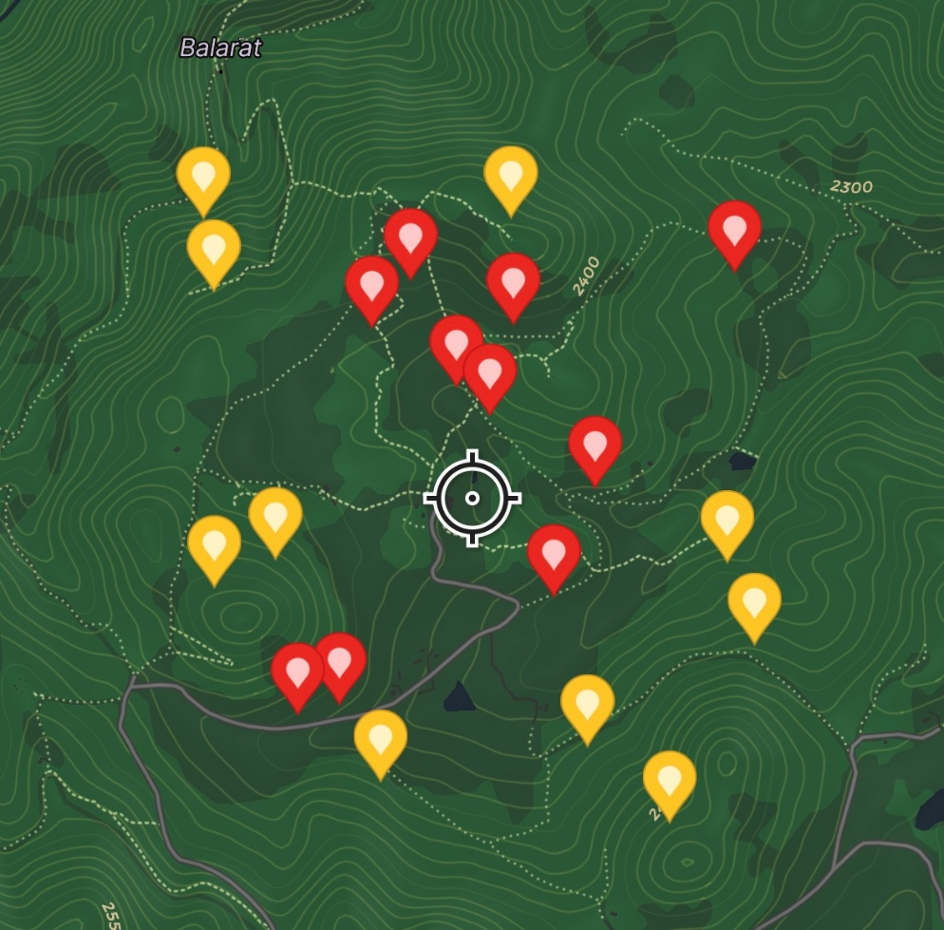

Figure 3. Screenshot of study zones (north-facing = yellow, south-facing = red) on *Avenza Maps*.

***2.4. Data Analysis***

Bar charts [Figure 4] and pie charts [Figure 5] were made to visually compare the abundance of different tree species along north-facing and south-facing slopes, as well as to compare species diversity between them.

To compare between the relative abundance of Ponderosa pine trees on north-facing and south-facing slopes [Figure 5], a two-tailed, 2-proportion z-test was conducted at a significance level of p < 0.05.

The polar scatterplot visualizing the spatial distribution of aspects among Douglas fir and Ponderosa pine trees [Figure 6] was made in Python using the *matplotlib.pyplot*, *numpy*, and *pandas* libraries, and it was run in Google Colab. The Python code for this polar scatterplot was generated with Claude and then manually tweaked tweaked (all code and raw data for this project can be found under **Repository**).

To determine whether the spatial distribution of aspects is different between Douglas fir and Ponderosa pine, a Watson U2 two-sample test was performed in R version 4.5.1 with the *circular* package (version 0.5-1). The Watson U² test compares two circular distributions to determine if they originate from the same population. The R code for this Watson U2 test and the corresponding rose diagrams was generated with Claude and then manually tweaked. Concentration values (ρ) range from 0 (uniform distribution) to 1 (perfectly concentrated). This code was also used to generate the rose diagrams in [Figure 7].

**3. Results and Discussion**

***3.1. Average Tree Abundances and Tree Diversity***

The results of the data collection across the 20 study zones are shown in [Table 2] and visualized in [Figure 4].

|  |  |  |  |  |  |  |
| --- | --- | --- | --- | --- | --- | --- |
| Direction | Avg. # D. fir | Avg. # P. pine | Avg. # R.M. Juniper | Avg. # R.M. Maple | Avg. # Wax Currant | Avg. Total # Trees |
| N | 65.4 | 14.3 | 2 | 0.2 | 0.2 | 82.1 |
| S | 0.2 | 10.5 | 0 | 0 | 0.1 | 10.8 |
| Overall | 32.8 | 12.4 | 1 | 0.1 | 0.15 | 46.45 |

**Table 2.** Average study zone tree counts (north-facing (N), south-facing (S), and overall).

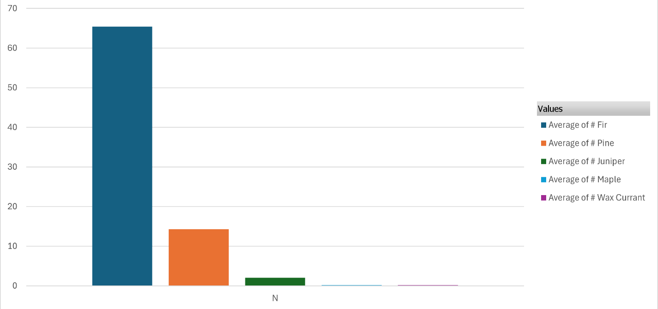**(a)**

**(b)**

**Figure 4.** Bar charts comparing average tree counts between north-facing **(a)** and south-facing **(b)** zones.

These results suggest that tree diversity is greater on the north-facing slopes of the Front Range than those facing south. A greater number of unique species were observed in north-facing study zones (5) than were found in south-facing zones (3).

***3.2. Ponderosa Pine Relative Abundance***

To test whether the relative abundance (RA) of Ponderosa pine trees varies between north-facing and south-facing slopes, a two-tailed, 2-proportion z-test was conducted with the following null (H0) and alternative (H1) hypotheses:

**H0: North-facing P. pine RA = south-facing P. pine RA**

**H1: North-facing P. pine RA south-facing P. pine RA**

The relative abundances of each tree species on north-facing and south-facing zones are visualized in [Figure 5]:

**Figure 5.** Relative abundances of trees on north-facing and south-facing slopes.

The results of the two-tailed z-test (P1 = 0.174, N1 = 10, P2 = 0.972, N2 = 10) yielded a z-score of -3.6074 and a statistically significant p-value of 0.0003. As such, the data strongly suggest that Ponderosa pine trees make up a greater proportion of all trees on south-facing slopes than they do on north-facing slopes. H0 is rejected.

***3.3. Spatial Distribution of Aspects***

A polar scatterplot visualizing the number of Douglas fir and Ponderosa pine trees in each study zone by aspect is shown in [Figure 6]:

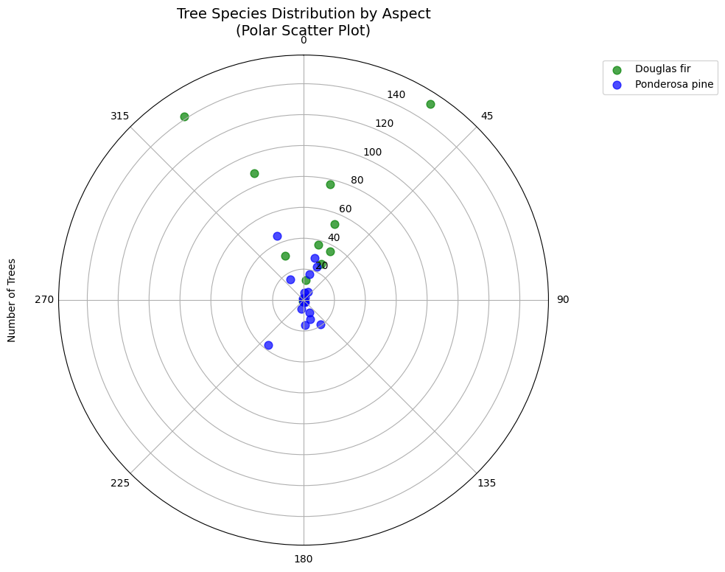

**Figure 6.** Polar scatterplot of Douglas fir and Ponderosa pine counts by aspect. Individual tree counts weighted by abundance. Made with Python, using the *matplotlib.pyplot*, *numpy*, and *pandas* libraries, in *Google Colab*.

To confirm that the spatial distribution of aspects varies between Douglas fir and Ponderosa pine trees, a Watson U2 two-sample test was performed using the circular package (version 0.5-1) in R version 4.5.1. The spatial distribution of aspects for Douglas fir and Ponderosa pine are visualized in the following rose diagrams:

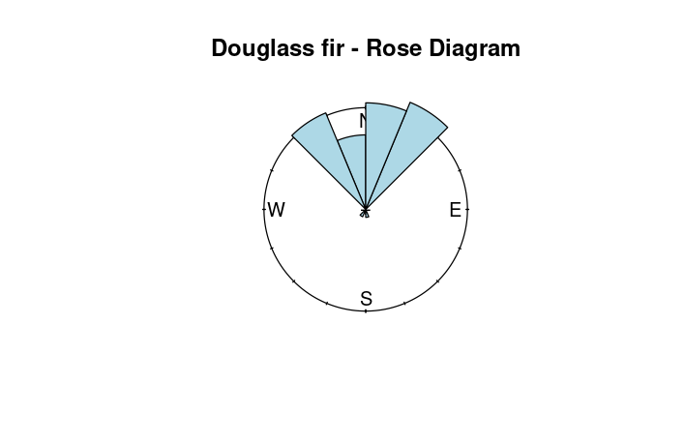

**Figure 7.** Rose diagrams of Douglas fir and Ponderosa pine counts by aspect (16 bins, 22.5° each). Created in R via RStudio with the *circular* library.

The Watson U2 test yielded a test statistic of 1.6082 and a statistically significant p-value of < 0.001. Thus, these test results suggest a significant difference in the spatial distribution of aspects between Douglas fir and Ponderosa pine. Douglas fir are highly concentrated on north-facing slopes (ρ = 0.89), while Ponderosa pine trees are much more uniformly distributed across aspects (ρ = 0.167).

**4. Conclusions**

Slope aspect proved to be a highly influential factor in shaping the abundance, diversity, and distribution of trees in the Colorado Front Range. It was found that the overall abundance of trees is significantly higher on north-facing slopes than it is on south-facing slopes. Furthermore, north-facing slopes host a greater diversity of tree species than south-facing slopes. Lastly, the data revealed that Ponderosa pine exhibit a relatively uniform distribution between northern and southern aspects, while Douglas fir are concentrated along north-facing slopes.

Since this study only examined northern and southern aspects, it would be useful for future studies to investigate the same patterns on east-facing and west-facing slopes as well. This could help provide a more complete picture of the relationship between slope aspect and the abundance, distribution, and diversity of trees.

The results of this study could have practical applications in forest management and wildfire prevention. In light of the 2020 Cal-Wood Wildfire, the patterns revealed in this study could be used to guide restoration efforts.

**Repository**

All raw data and code can be found at <https://github.com/smithberg/EcoFS-Research-Project>.

**References**

1. Hanberry, B., Timberlake, T., Clark, N., Miller, B., & Peterson, C. (n.d.). Scope, Setting, and Purpose of the Colorado Front Range Climate Change Vulnerability Assessment for National Forests Scope. In *USDA Forest Service RMRS*. Retrieved August 14, 2025, from <https://www.fs.usda.gov/rm/pubs_series/rmrs/gtr/rmrs_gtr438/rmrs_gtr438_chap01.pdf>
2. Hansen-Bristow, K. J., & Ives, J. D. (1984). CHANGES IN THE FOREST-ALPINE TUNDRA ECOTONE: COLORADO FRONT RANGE. *Physical Geography*, *5*(2), 186–197. <https://doi.org/10.1080/02723646.1984.10642252>
3. *2020 Cal-Wood and Lefthand Canyon Fires*. (2024, November 6). Boulder County. https://bouldercounty.gov/disasters/wildfires/calwood-lefthand-canyon
4. *About the Fire | Cal-Wood Education Center*. (2024). Cal-Wood Ed Center. <https://www.calwood.org/about-the-fire>
5. Dyer, J. M. (2009). Assessing topographic patterns in moisture use and stress using a water balance approach. *Landscape Ecology*, *24*(3), 391–403. <https://doi.org/10.1007/s10980-008-9316-6>
6. Deng, L., Wang, K., Li, J., Zhao, G., & Shangguan, Z. (2016). Effect of soil moisture and atmospheric humidity on both plant productivity and diversity of native grasslands across the Loess Plateau, China. *Ecological Engineering*, *94*, 525–531. <https://doi.org/10.1016/j.ecoleng.2016.06.048>
7. *IPWA | Ecology, Flora & Fauna*. (2017). IPWA. <https://www.indianpeakswilderness.org/ecology-flora-fauna>
8. Petros, M., Puffy Soundy, & Martin Makgose Maboko. (2024). Effects of Rainfall Intensity and Slope on Infiltration Rate, Soil Losses, Runoff and Nitrogen Leaching from Different Nitrogen Sources with a Rainfall Simulator. *Sustainability*, *16*(11), 4477–4477. <https://doi.org/10.3390/su16114477>